Case Study: Kajodi Devi
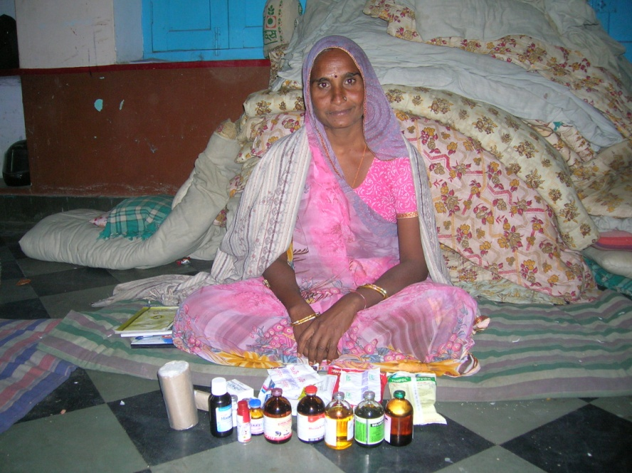

Kajori Devi was born into a middle-level farming household and belonged to the SC community. In spite of this, her parents encouraged her to go to school regularly. Her mother unburdened her of household chores and told her to concentrate on her studies. However, in accordance with the prevailing social customs, she got married at the age of 11. Due to pressure from her in-laws, she had to discontinue her studies after Class VIII. This left a deep mark on her. Later, when it came to her own daughter, she insisted on having the girl complete her schooling, in spite of strong resistance from her husband’s family. Kajori Devi took a loan from the SHG and used it to buy a sewing machine. She encouraged her daughter to do some stitching after school hours to finance her education herself. The girl is now studying nursing.
When Kajori Devi got married, her husband’s family owned about 5 bigha (4 bigha = 1 ha) of dry land and two buffaloes. She was expected to do the domestic work. This was neither satisfying for her, nor was the family happy with the quality of her work. Her husband, who worked with furniture, developed TB and she had to toil in the farm, work in other people’s houses and ultimately was forced to sell off 2 bhiga land for his treatment.
When a CIG was formed in her village in 2005, she was selected as the chair and put in charge of all bank-related transactions, since she was the only literate woman. She was more interested in this job than in performing domestic chores. She managed to buy a buffalo and by selling some of the milk produced, she was able to earn Rs. 2000 incremental income per month, which eased her situation somewhat.
When milk collection started in the village, Kajori Devi was appointed as a para-professional by SRIJAN. She was given the job of maintaining the records of the group and started receiving remuneration for her work in 2007. Gradually, her responsibilities grew. She soon assisted six groups in three neighbouring villages. She started assuming a leadership role and was actively involved in the promotion of 12 new SHGs.
She then volunteered to visit Andhra Pradesh. By this time, her husband had started supporting her. She came back from Andhra Pradesh feeling quite inspired. She started campaigning for a women’s dairy in her own area, and played an important role in getting the women of her village to stand up for themselves.
.After linking with the SHG program and becoming financially independent she started to participate actively in SRIJAN’s dairy program. She became the leader of her cluster and eventually, the chairperson of the Maitree Mahila Mandal federation.
Kajori Devi also displayed several other leadership qualities. Once when one of the local schools did not have enough teachers to hold all the classes, she, along with a group of women, locked the school premises till the district authorities agreed to post two teachers there. As this had no direct connection with the dairy-related activities of SRIJAN, she did not involve the NGO. On another occasion (before the Maitree Dairy initiative), one of the local milk traders was unwilling to pay the women the money due for the milk they had supplied. Kajori Devi and a group of women hired a van, went to the dairy and lifted its dump tank. Before taking this initiative, she took care to give the collector written intimation of her plan and invited the reporters of a few local newspapers to cover the event. Full disclosure was made of the amounts due to the women.
Kajodi Devi has received social recognition and economic independence and is very passionate to empower other women so they may too achieve the same. Her future plans include opening a shop selling animal feed & vet care materials at her door step, educating her children to the highest possible levels and constructing a new house. She is a fiercely devoted member of the Federation, and is very positive about taking it to new heights.

